CSB 353: Compiler Design

Project Report (Parser for P3SQL)

Submitted By:

Prashant Borkar (191210036)

Prem Kumar (191210037)

Prince Kumar (191210038)

Submitted To: Dr. Shelly Sachdeva

Department of Computer Science and Engineering



NATIONAL INSTITUTE OF TECHNOLOGY DELHI

2019-2023

Table of Content

|  |  |  |
| --- | --- | --- |
| S No. | Content | Page No |
| 1 | Introduction | 3 |
| 2 | Lexical Analyzer | 5 |
| 3 | Syntax Analyzer | 7 |
| 4 | Semantic Analyzer | 9 |
| 5 | Execution | 10 |
| 6 | References | 11 |

Introduction

Our project aims to undertake a sequence of experiments to design and implement various phases of a Parser for a Structured Query language which we have named as P3SQL, it is a subset of SQL.

We have developed this in python making the use of lex and yacc and we use pymysql to connect with MySQL Database.

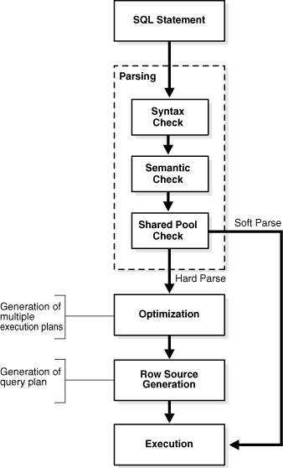

Covered Scope:

* **Type**
  + STRING
  + INTEGER
* **Statement**
  + CREATE DATABASE
  + DROP DATABASE
  + SHOW DATABASES
  + USE DATABASE
  + CREATE TABLE
  + DROP TABLE
  + SHOW TABLES
  + INSERT
  + DELETE
  + UPDATE
  + SELECT

Inputs can be given through the input file or through terminal.

Requirements:

* Python 3
* PLY

PLY is yet another implementation of lex and yacc for Python. Some notable features include the fact that it is implemented entirely in Python and it uses LALR(1) parsing which is efficient and well suited for larger grammars.

* PyMySQL

This package contains a pure-Python MySQL client library.

* MySQL
* VS Code(ide)

Phases:

* Lexical Analyzer:

Identification of Keywords, Identifiers, Operators (Relational, Logical and Arithmetic), Punctuators, Constants (Integer, Character) and String Literals with invalid string error handling. Parenthesis matching with error reporting.

Following are the valid tokens:

tokens = [  
 'create',  
 'use',  
 'show',  
 'insert',  
 'select',  
 'update',  
 'delete',  
 'drop',  
 'exit',  
 'databases',  
 'database',  
 'tables',  
 'table',  
 'into',  
 'values',  
 'from',  
 'all',  
 'where',  
 'set',  
 'compare',  
 'logic',  
 'char',  
 'int',  
 'id',  
 'number',  
 'string',  
 'comma',  
 'semicolon',  
 'left_paren',  
 'right_paren'  
]

And tokens are defined as follows using regular expression -

def t_create(t):  
 *r"""(C|c)(R|r)(E|e)(A|a)(T|t)(E|e)"""* t.value = "CREATE"  
 return t

Output for Lexical Analyzer

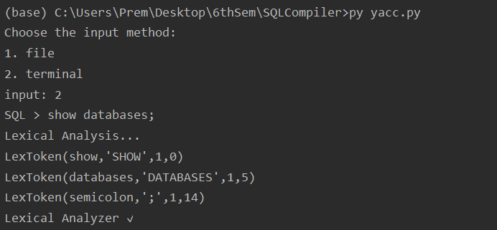

* Syntax Analyzer:

In this phase it receives the inputs, in the form of tokens, from lexical analyzers. Checks if the expressions from these tokens are syntactically correct or not.

Production rules are as follows -

Rule 0 S' -> start  
Rule 1 start -> statement  
Rule 2 statement -> <empty>  
Rule 3 statement -> create_db statement  
Rule 4 statement -> show_db statement  
Rule 5 statement -> drop_db statement  
Rule 6 statement -> use_db statement  
Rule 7 statement -> create_tb statement  
Rule 8 statement -> show_tb statement  
Rule 9 statement -> drop_tb statement  
Rule 10 statement -> insert_tb statement  
Rule 11 statement -> delete_tb statement  
Rule 12 statement -> update_tb statement  
Rule 13 statement -> select_tb statement  
Rule 14 statement -> exit_db statement  
Rule 15 create_db -> create database id semicolon  
Rule 16 show_db -> show databases semicolon  
Rule 17 drop_db -> drop database id semicolon  
Rule 18 use_db -> use id semicolon  
Rule 19 create_tb -> create table id left_paren cols right_paren semicolon   
Rule 20 cols -> id type col  
Rule 21 type -> int  
Rule 22 type -> char left_paren number right_paren  
Rule 23 col -> <empty>  
Rule 24 col -> comma id type col  
Rule 25 show_tb -> show tables semicolon  
Rule 26 drop_tb -> drop table id semicolon  
Rule 27 insert_tb -> insert into tb_name values left_paren value_cols right_paren semicolon  
Rule 28 tb_name -> id  
Rule 29 tb_name -> id left_paren id_cols right_paren  
Rule 30 id_cols -> id id_col  
Rule 31 id_col -> <empty>  
Rule 32 id_col -> comma id id_col  
Rule 33 value_cols -> string value_col  
Rule 34 value_cols -> number value_col  
Rule 35 value_col -> <empty>  
Rule 36 value_col -> comma string value_col  
Rule 37 value_col -> comma number value_col  
Rule 38 delete_tb -> delete from id where conditions semicolon  
Rule 39 conditions -> condition_col  
Rule 40 conditions -> left_paren conditions right_paren condition  
Rule 41 condition_col -> id compare id  
Rule 42 condition_col -> id compare number  
Rule 43 condition_col -> id compare string  
Rule 44 condition_col -> number compare id  
Rule 45 condition_col -> number compare string  
Rule 46 condition_col -> string compare id  
Rule 47 condition_col -> string compare string  
Rule 48 condition -> <empty>  
Rule 49 condition -> logic left_paren condition_col right_paren condition  
Rule 50 update_tb -> update id set update_cols semicolon  
Rule 51 update_tb -> update id set update_cols where conditions semicolon  
Rule 52 update_cols -> id compare number update_col  
Rule 53 update_cols -> id compare string update_col  
Rule 54 update_col -> <empty>  
Rule 55 update_col -> comma id compare number update_col  
Rule 56 update_col -> comma id compare string update_col  
Rule 57 select_tb -> select all from id_cols semicolon  
Rule 58 select_tb -> select id_cols from id_cols semicolon  
Rule 59 select_tb -> select all from id_cols where conditions semicolon  
Rule 60 select_tb -> select id_cols from id_cols where conditions semicolon  
Rule 61 exit_db -> exit semicolon

Output for Syntax Analyzer

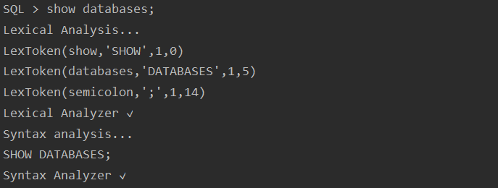

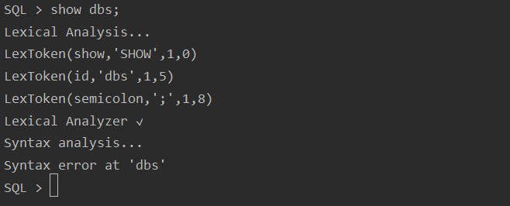

* Semantic Analyzer:

In this phase, we extract necessary semantic information from the P3SQL queries.

We are validating the following things –

Validation of Databases and Tables if already exists or not.

Validating values for insert and update queries.

Output for Semantic Analyzer

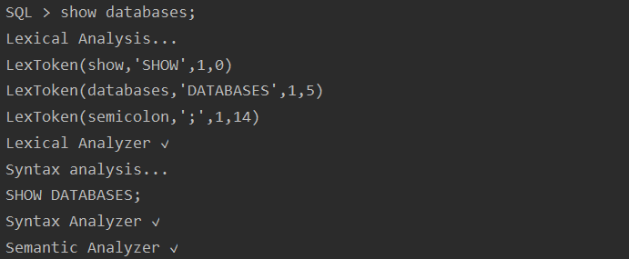

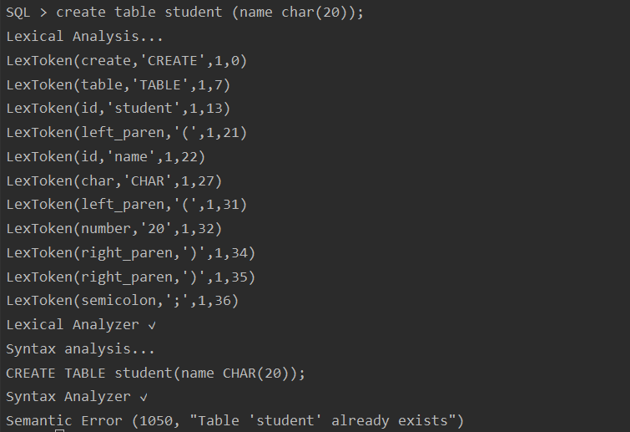

Execution:

Execution of P3SQL Query:

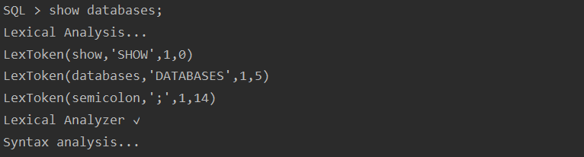 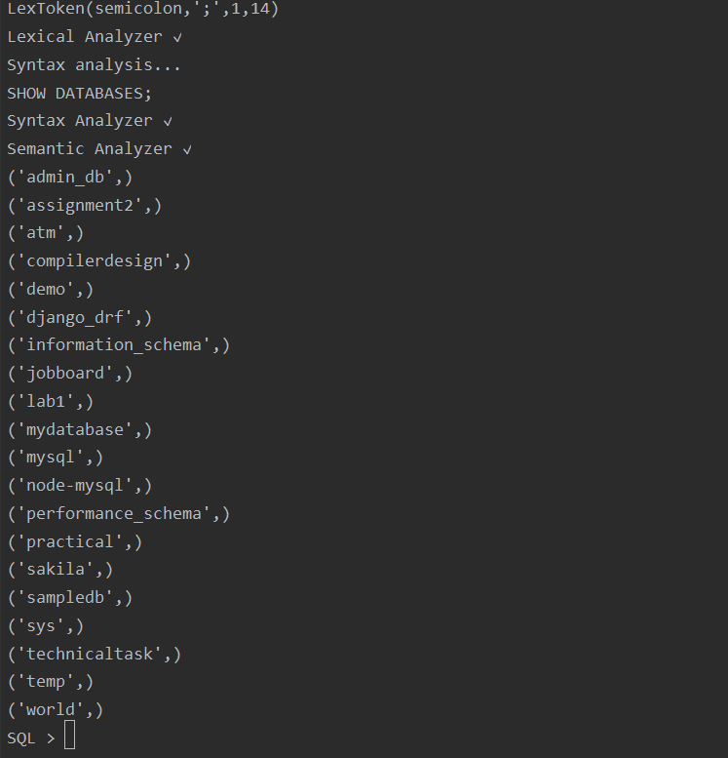

References

<https://www.dabeaz.com/ply/ply.html>

<https://ply.readthedocs.io/en/latest/>